**LAB 24: 3 WAYS OF INSERTING JAVASCRIPT IN AN HTML DOCUMENT**

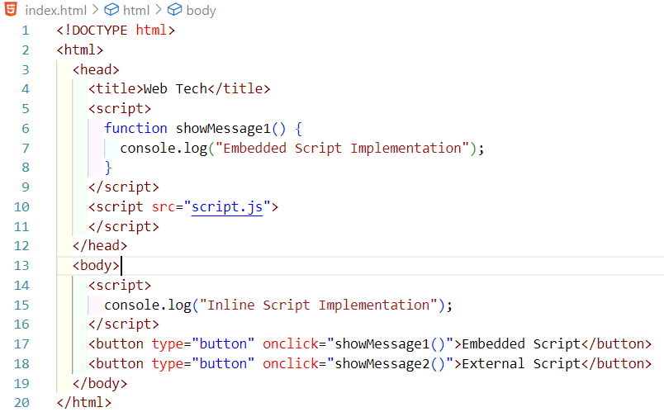

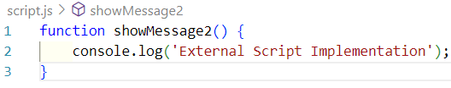

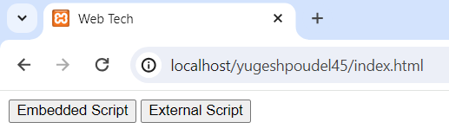

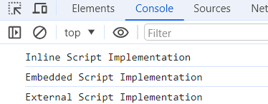

**LAB 25: EVENTS AND EVENT HANDLERS WITH EVENT ATTRIBUTES**

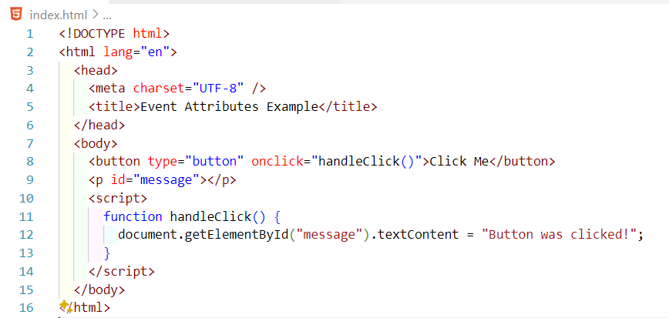

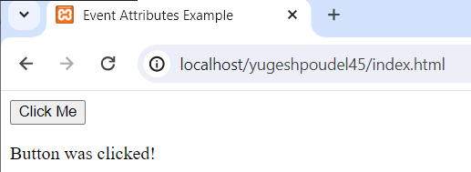

**LAB 25: TRIPLE EQUALS (===) VS. DOUBLE EQUALS (==) OPERATORS**

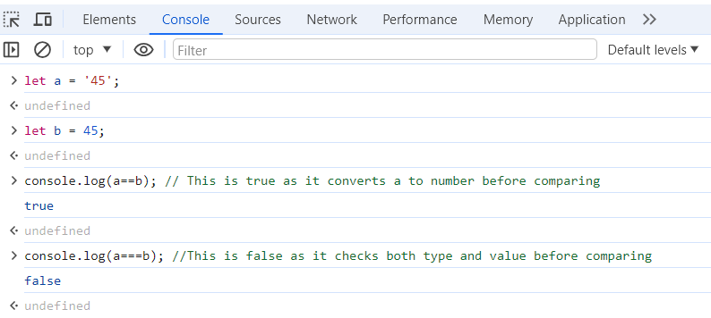

**LAB 26: CREATING STRING VARIABLES WITH DIFFERENT METHODS**

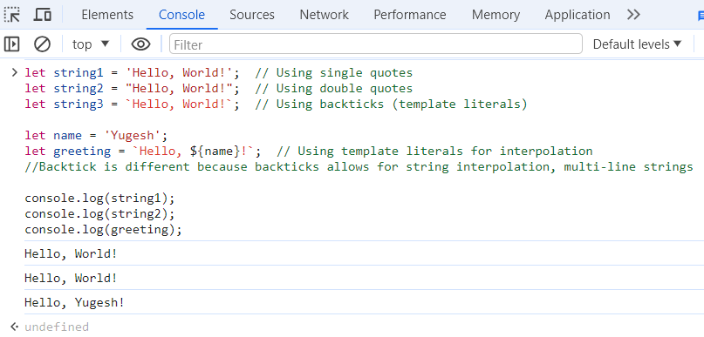

**LAB 27: CONFIRM AND PROMPT POPUP BOXES**

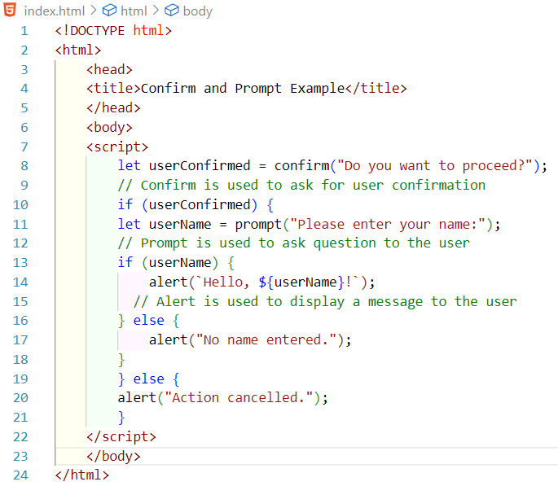

**OUTPUT**

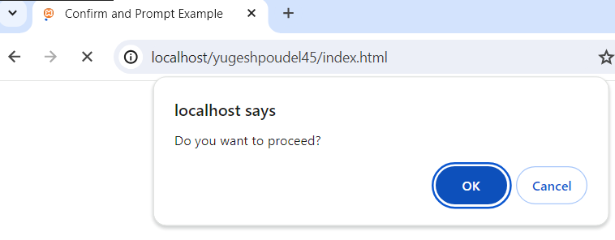

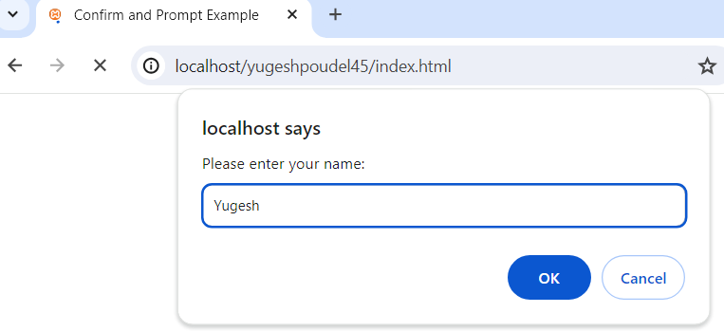

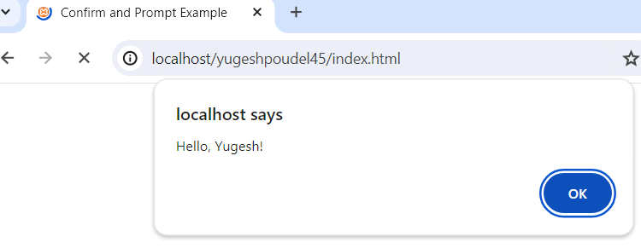

**LAB 28: CREATING AN OBJECT IN THREE DIFFERENT WAYS**

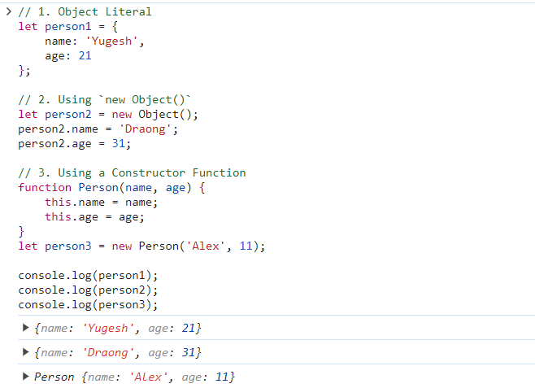

**LAB 29: ARRAY OF OBJECTS WITH PROPERTIES: ID, NAME, AND AGE**

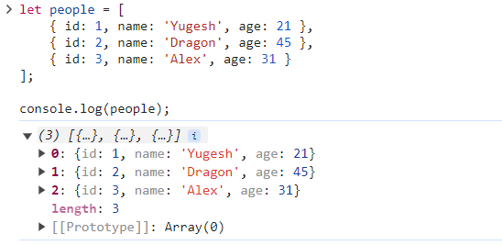

**LAB 30: FORM VALIDATION SCRIPT**

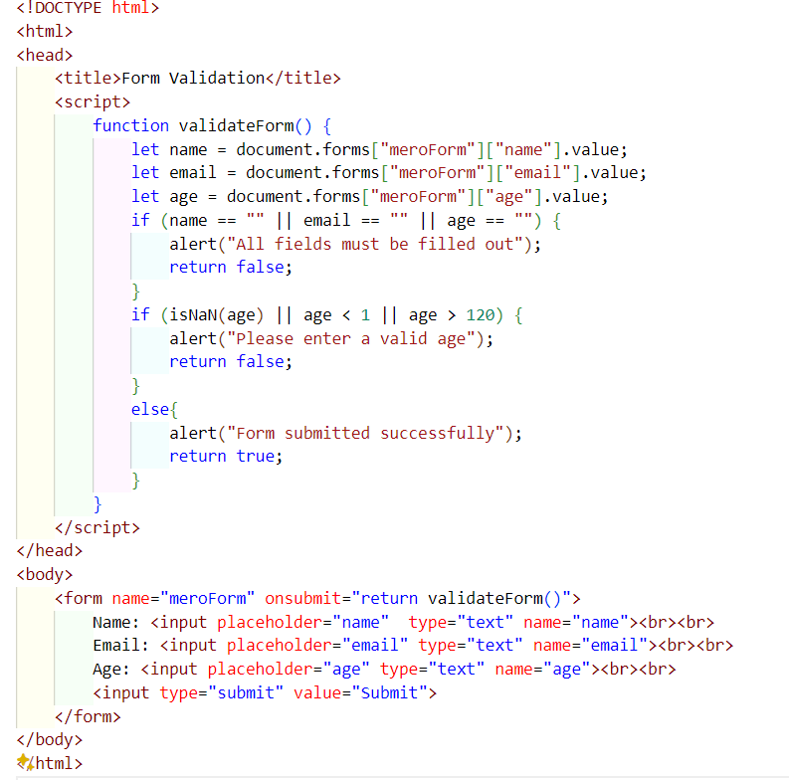

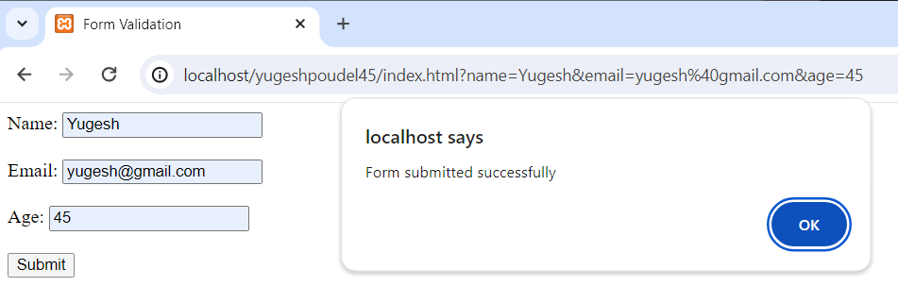

**LAB 31: WRITING COOKIES IN JAVASCRIPT**

